A Lightweight, Unsupervised Framework for Quantifying the Thermal Cooling Effect of Urban Tree Canopies from Street-Level Imagery

Swarnalatha P, Devank Gupta, Aayush Khanna
Email id : pswarnalatha221@gmail.com ph no : +91 94436 30735
ABSTRACT
The Urban Heat Island (UHI) phenomenon poses a major challenge to sustainable urban development, emphasizing the need for quantitative tools to evaluate the thermal benefits of green infrastructure. Although deep learning–based approaches have been widely adopted for analyzing street-level imagery (SLI), they remain resource-intensive and heavily reliant on labeled datasets. This paper introduces an efficient, unsupervised computational framework that estimates the cooling potential of urban tree canopies without the need for deep learning models. The method employs a three-phase pipeline: (1) canopy extraction using Simple Linear Iterative Clustering (SLIC) superpixels combined with vegetation index filtering (VARI) and morphological enhancement; (2) a physics-based model that predicts temperature reduction (ΔT) based on canopy health and relative area; and (3) visualization of spatial cooling patterns through a synthetic thermal map. The framework provides a scalable, interpretable, and computationally lightweight alternative for estimating individual tree-level cooling effects, facilitating evidence-based urban climate planning.
Keywords: Urban Heat Island (UHI), Unsupervised Segmentation, Computer Vision, Superpixels, SLIC, Street-Level Imagery, Thermal Modeling, Green Infrastructure, Smart Cities.

1. INTRODUCTION
Urbanization has accelerated dramatically over the past century, resulting in built environments dominated by impervious materials such as asphalt and concrete. These surfaces absorb solar radiation and retain heat, creating the Urban Heat Island (UHI) effect—an increase in temperature observed in cities compared to their rural surroundings. The UHI effect intensifies energy consumption, degrades air quality, and poses significant health risks, especially to vulnerable communities.
Among various mitigation strategies, urban trees provide the most direct and natural form of temperature moderation through shading and evapotranspiration. These mechanisms reduce local air and surface temperatures, enhancing outdoor comfort and decreasing building cooling demands. However, effective integration of vegetation into urban design requires quantitative methods to assess the cooling performance of existing tree canopies.
Traditional measurement techniques, such as manual surveys and satellite-based thermal imaging, either lack spatial resolution or are too costly and time-consuming. Deep learning models have recently gained traction for analyzing SLI, offering high accuracy but at the cost of interpretability and computational demand. To overcome these challenges, this study presents a lightweight, unsupervised framework that combines classical computer vision with a physics-inspired thermal model to quantify canopy-level cooling effects efficiently and transparently.

2. RELATED WORK
The use of street-level imagery for urban vegetation analysis has evolved significantly. Seiferling et al. (2017) pioneered the Green View Index (GVI), a simple metric quantifying visible greenery from SLI. While GVI demonstrated the feasibility of using such imagery for environmental monitoring, it provided only descriptive insights rather than predictive thermal assessments.
Advancements in deep learning segmentation, particularly using models like Mask R-CNN, dramatically improved vegetation identification accuracy. For instance, the Treepedia 2.0 project leveraged convolutional neural networks to map urban trees with high precision. However, deep learning’s reliance on labeled data and high-end hardware limits its accessibility and interpretability.
This research revives unsupervised approaches—specifically the SLIC superpixel algorithm—allowing image segmentation based purely on pixel color and texture similarity. By integrating this segmentation with a vegetation index (VARI) and a physically grounded thermal model, the framework offers a balance between computational efficiency and functional depth.

3. METHODOLOGY
3.1 Comparative Overview of Approaches
Greenery quantification techniques can be categorized into supervised (deep learning) and unsupervised (classical vision) paradigms:
- Supervised Methods:
  - Advantages: Exceptional accuracy; ability to distinguish vegetation from other objects.
  - Limitations: Dependence on massive labeled datasets and GPU-based computation; poor interpretability.
- Unsupervised Methods (Proposed Framework):
  - Advantages: Lightweight, requires no training data, interpretable results through explicit thresholds.
  - Limitations: Moderately less accurate; may misclassify non-tree green objects.
Given the goal of scalable and interpretable modeling, this research adopts the unsupervised approach for broader urban applicability.

3.2 Framework Design
The proposed workflow consists of three primary stages: segmentation, thermal modeling, and visualization.
Stage 1: Canopy Segmentation
The initial stage isolates tree canopies automatically using a sequence of image-processing operations.
- Superpixel Generation:
The SLIC algorithm divides the image into compact, visually consistent regions, simplifying the image into manageable superpixels.
- Vegetation Filtering:
A VARI map is calculated to assess pixel-level greenness. Superpixels exceeding a VARI threshold (≥0.1) and area criterion (>400 pixels) are marked as vegetation.
- Morphological Refinement:
Morphological operations remove small artifacts and fill internal gaps, producing a cohesive canopy mask.
- Object Separation:
Connected component analysis distinguishes individual tree crowns, ensuring unique identification of each canopy.

Stage 2: Thermal Cooling Estimation
Once canopy masks are established, the model estimates cooling intensity using a simplified physics-based formula.
Key components include:
- Health Factor (F_health): The normalized mean VARI value representing canopy vigor and evapotranspiration potential.
- Size Factor (F_size): A relative area parameter computed as the square root of the canopy area divided by total image area.
The estimated cooling for each canopy ($ΔT$) is given by:
$$ΔT=C_{max}×(F_{health}×F_{size})$$
where $C_{max}$(typically 8°C) represents the upper bound of cooling potential. The computed results—temperature reduction, area, and coordinates—are consolidated for downstream visualization.

Stage 3: Visualization and Output Generation
The results are visualized through overlays and tabulated data summaries:
- Mask Overlay: Displays detected tree canopies over the original image, each in a distinct color.
- Annotated Image: Highlights individual trees with bounding boxes and their predicted ΔT values.
- Virtual Thermal Map: Simulates surface temperature distribution using a thermal colormap applied to the cooling estimates relative to a base temperature of 40°C.
- Tabular Summary: Presents canopy-specific metrics such as ID, VARI, area, and cooling intensity.

Figure 1: SLIC segmentation output illustrating superpixel distribution.
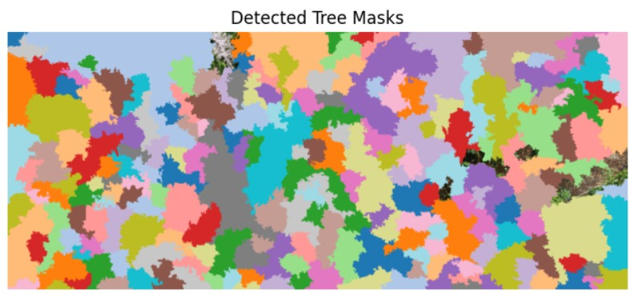

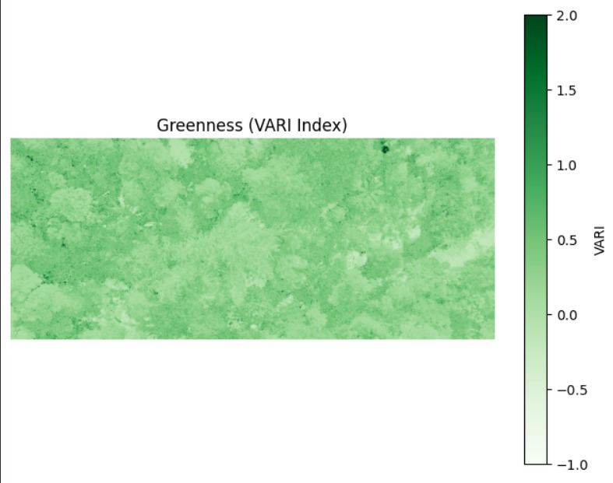
Figure 2: VARI greenness index map showing vegetation vitality.

Figure 3: Virtual thermal visualization highlighting predicted cooling zones.
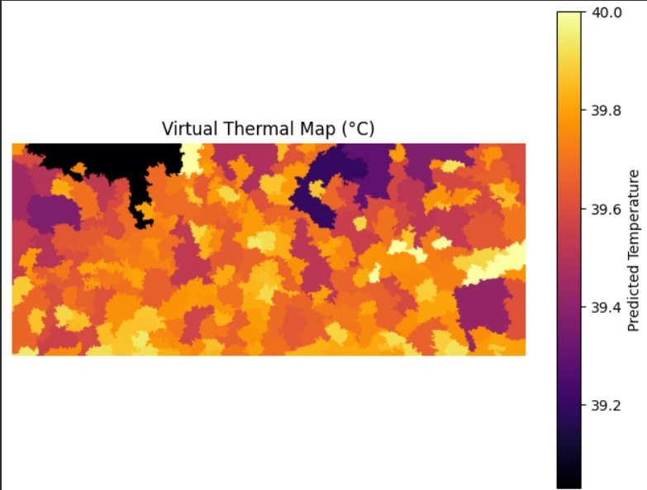

Table 1: Sample canopy-wise quantitative results.
id | area_px | mean_vari | est_cooling_C
1 | 68,210 | 0.31 | -2.85
2 | 12,450 | 0.23 | -0.98

4. RESULTS AND DISCUSSION
4.1 Visual Evaluation
The framework effectively segments dense canopies and produces coherent thermal predictions. Figures 1–3 display a consistent correlation between higher VARI values and lower modeled temperatures, reinforcing the validity of the model’s physics-based assumptions.
4.2 Quantitative Evaluation
Table 1 presents canopy-level thermal estimates, demonstrating the framework’s capacity to generate interpretable, object-specific cooling data.

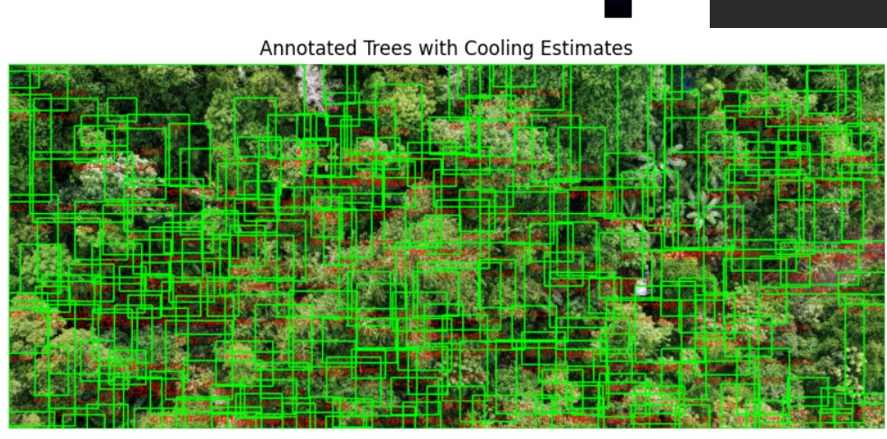

The per-canopy output provides actionable information for targeted interventions in urban greening strategies.
4.3 Analytical Insights
The unsupervised framework offers several advantages—transparency, speed, and independence from training data—making it suitable for citywide applications. Although parameter tuning is required for optimal accuracy, its interpretability makes it a practical analytical tool for sustainable urban design.

5. CONCLUSION
This paper presents a lightweight, unsupervised computational approach for estimating the thermal cooling contribution of urban tree canopies using street-level imagery. By integrating SLIC superpixel segmentation with a physics-based thermal model, the framework provides interpretable temperature reduction estimates (ΔT °C) without the computational expense of deep learning.
Its simplicity, scalability, and interpretability make it a valuable tool for climate-sensitive urban planning. Future work should focus on refining the model through empirical calibration with field temperature data and incorporating 3D canopy metrics (e.g., LiDAR-derived volume) to enhance accuracy and real-world applicability.

6. REFERENCES
T. R. Oke, "The energetic basis of the urban heat island," Quarterly Journal of the Royal Meteorological Society, vol. 108, no. 455, pp. 1–24, 1982.
P. A. Y. D. Santamouris, "Cooling the cities – A review of reflective and green roof mitigation technologies to fight heat island and improve comfort in urban environments," Solar Energy, vol. 103, pp. 682–703, 2014.
S. L. Harlan, A. J. Brazel, L. Prashad, W. L. Stefanov, and L. Larsen, "Neighborhood microclimates and vulnerability to heat stress," Social Science & Medicine, vol. 63, no. 11, pp. 2847–2863, 2006.
E. G. McPherson, D. J. Nowak, and R. A. Rowntree, "Chicago's urban forest ecosystem: results of the Chicago Urban Forest Climate Project," General Technical Report NE-186, U.S. Department of Agriculture, Forest Service, 1994.
I. Seiferling, N. Naik, C. Ratti, and R. Proulx, "Green streets − Quantifying and mapping urban trees with street-level imagery and computer vision," Landscape and Urban Planning, vol. 165, pp. 93–101, 2017.
A. Berland, M. H. T. A. T. M. M. A. Arciniegas, "Mapping trees along urban street networks with deep learning and street-level imagery," ISPRS Journal of Photogrammetry and Remote Sensing, vol. 175, pp. 32–44, 2021.
Y. Cai, W. Li, et al., "Treepedia 2.0: Applying Deep Learning for Large-Scale Quantification of Urban Tree Cover," Proceedings of the 24th ACM SIGKDD International Conference on Knowledge Discovery & Data Mining, 2018.
R. Achanta, A. Shaji, K. Smith, A. Lucchi, P. Fua, and S. Süsstrunk, "SLIC Superpixels Compared to State-of-the-art Superpixel Methods," IEEE Transactions on Pattern Analysis and Machine Intelligence, vol. 34, no. 11, pp. 2274–2282, 2012.
A. A. Gitelson, et al., "Vegetation and Soil Lines in Visible Spectral Space: A Concept and Technique for Remote Estimation of Vegetation Fraction," International Journal of Remote Sensing, vol. 23, pp. 2537−2562, 2002.

